NOTE: This is a general overview and is not a replacement for the readings.
Introduction
Randomized controlled trials (RCT) are done to study the beneficial effects of “treatment”. It is unethical to study harm using a RCT although sometimes harm results from therapies. Treatment is a generic term and refers to drugs, surgery, radiation, screening programs, healthcare delivery changes, etc. RCTs (when conducted properly) are considered less biased than observational studies.

What are RCTs?
RCTs are experimental studies in which researchers perform an experiment and purposely assign one group in the study to the new “treatment” (the intervention group) and the other group to a comparison “treatment” (control or comparison group). Assignment to treatment groups is done using a procedure called randomization. RCTs look just like prospective cohort studies except that researchers choose the cohorts (intervention group or cohort and the comparator group or cohort) patients belong to instead of them occurring naturally (as they do in an observational study).
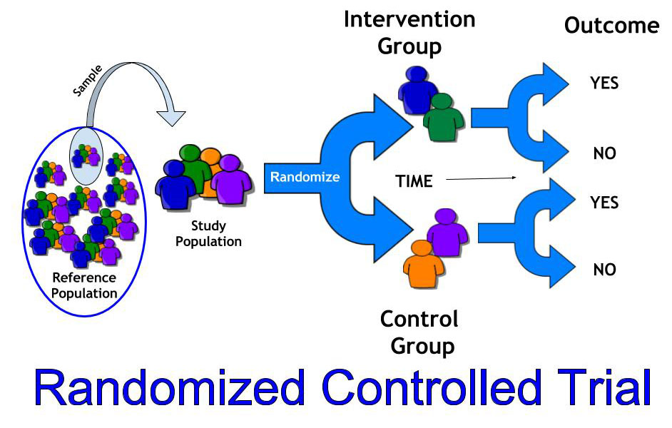
Make sure to review the differences between phase I, II, III, and IV (or post-marketing surveillance) trials.

What is randomization and why is it important?
One of the main problems with observational studies is confounding. Confounders are factors that distort the effect of the exposure on the outcome (they cause over or under estimation of the effect) . For example, age is usually a confounder. Let’s say we are interested in studying the effects of smoking on death. We would need two groups patients: smokers and nonsmokers and then compare the death rates between them. Older people die more than younger people. For this example, assume that older people smoke more than younger people. If we see a greater death rate in smokers is it because smoking is harmful or is it because smokers are older and older people die more? To study this properly we need to control for age (i.e. make it equal between the smokers and nonsmokers) and then study the effect of smoking on death. Make sure to read or watch the video about confounding. This is a very important concept to understand.
Randomization is used to assign patients to the intervention and control arms of a RCT. Each patient has a random chance, like a coin flip, to be assigned to each arm of the study. Randomization serves 2 main roles. First, it prevents researchers from selectively enrolling patients into one arm or the study or the other based on patient characteristics (it prevents selection bias). For example, putting really sick patients in one arm and healthier ones in the other based on your beliefs of the benefits of one arm over the other. Second, randomization equalizes potential confounders and prognostic factors between the arms of the study. This is important because we are conducting an experiment and we only want to see the effect of the intervention. We can’t have other things (confounders) interfering with the effects. To see how powerful randomization is look at Table 1 in this randomized controlled trial (click on the “Tables” tab and expand “Table 1”) and see how balanced the groups are for almost every factor (“baseline characteristics”).

What is blinding and why is it important?
Blinding is a technique to keep study participants unaware of the arm they are assigned to. It can occur at 2 points in a study: blinding of the randomization scheme (this is called concealed allocation) and blinding of everything post randomization. Blinding is important because beliefs can impact outcomes, especially subjective outcomes like pain. Study participants usually believe that the “new treatment” is better and want to be assigned to receive the “new treatment”. They may become disappointed if they figure out they didn’t get the “new treatment” and this disappointment could impact their behaviors (like continuing to participate in all the study requirements) and interpretations of study outcomes (e.g. disappointment might make them underestimate how good they feel or overestimate how bad they feel).
In drug studies blinding is often accomplished by using a placebo. Placebos are given to the control arm. Placebos are indistinguishable from active treatment. They look, feel, smell, and taste the same but they don’t have any active ingredients. They are essentially sugar pills. For studies in which giving a placebo is unethical (because proven therapy is available) special techniques (coded bottles, covered IV bags, using dummy dose adjustments, etc) are carried out to try to keep study participants unaware of treatment assignment.
For some interventions, blinding is almost impossible. For example, it would be hard (but not impossible) to blind participants in a study comparing surgical treatment of osteoarthritis of the knee to conservative therapy (acetaminophen and physical therapy). In this case, the best you can do is blind those who determine study outcomes (the outcome adjudicators) so that they have no knowledge of which arm a participant is in when they review the records to determine if a participant had an outcome or not.
There are classically 3 types of blinding as shown in the cartoon below.
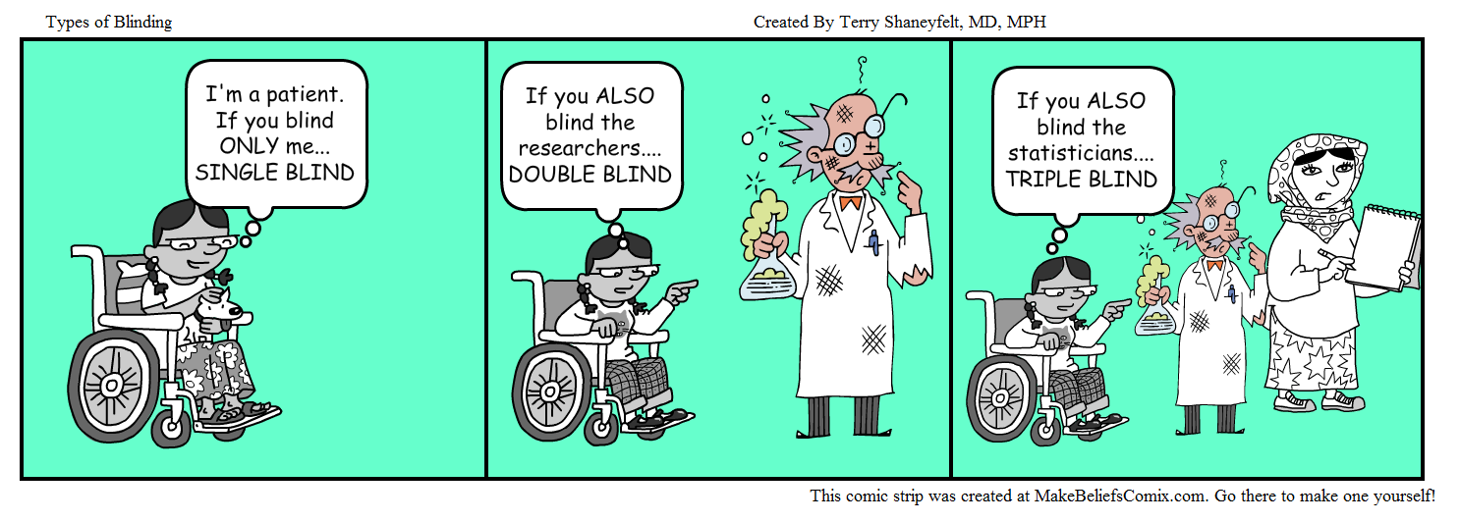

What is the difference between efficacy and effectiveness?
RCTs can be designed to study the efficacy of a “treatment” or the effectiveness of a “treatment”. Efficacy studies determine if the “treatment” works under the ideal circumstances of a strictly conducted trial. Most RCTs are efficacy studies. Effectiveness studies determine if the “treatment” works under more usual, real world, care circumstances. These are becoming more common as we have recognized that ideal study conditions usually don’t reflect actual practice. They allow for more patient and doctor choice than efficacy studies. Review Figure 9.7 on page 143 of Fletcher to understand the main goal/strength/trade off of each type.

What is intention to treat and per-protocol analyses? Which is best?
Intention-to-treat (ITT) analysis means that once you are randomized you are analyzed in the group you were randomized to. It doesn’t matter if you didn’t get the assigned “treatment”. Your outcomes still count toward this group. The main reason this is done is to preserve the benefit of randomization (equalizing confounders). ITT analysis is conservative; meaning that it tends to err on the side of not finding a difference between arms of the study.
Per-protocol analysis means that your outcomes count in the group to which “treatment” you actually received. For example, let say you was randomized to receive surgery for a knee injury but instead opted to do conservative therapy (physical therapy) instead. Whatever happens to you counts against (or for) the conservative study group even though you were randomized to surgery. A big problem with per-protocol analysis is that if a substantial proportion of patients change out of one group to another the benefit of randomization might be gone and the study groups might be very unbalanced in terms of confounding factors.
In some studies, you will see both approaches to analysis undertaken. You can feel comfortable when they both give the same answer. If they don’t you have to really think about what the point of the study was (efficacy vs effectiveness) and if the study was a superiority or a non-inferiority study.

